- Create custom field
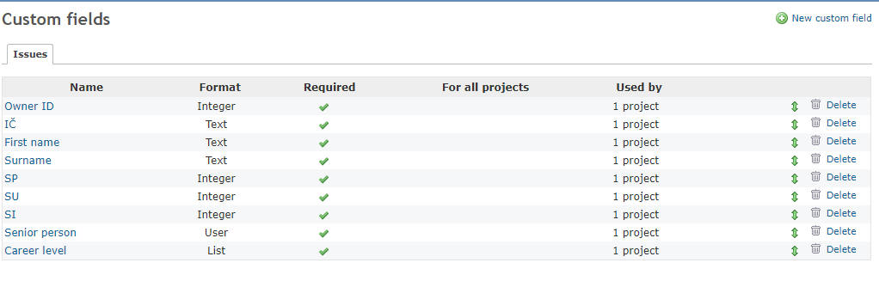
- Current view detail issue
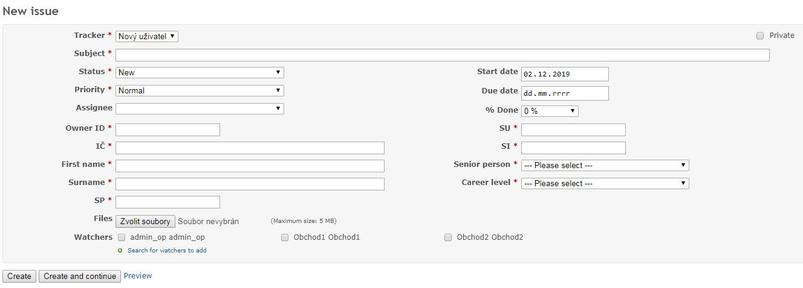

- My idea – for example : position and size value custom fields
Core fields
Can I change size and position of core fields ?
Custom fields
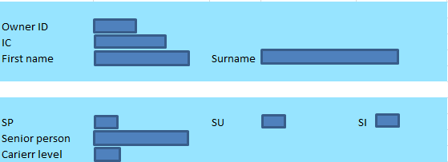

How can create this custome fields ?
Second example with name of group
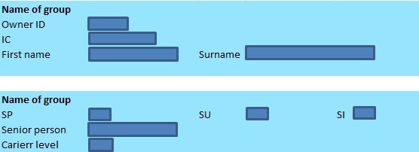

- Senior person is format „User“
How do I search this element?

I would like to use an element that is applied to watchers.

