These are members of a project:
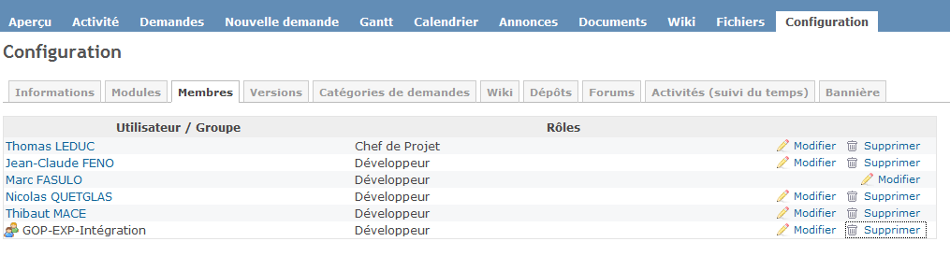
Marc FASULO is a member of the group GOP-EXP-Intégration. I can’t delete the group or the others members of the project when I push on button “Supprimer”. A “Loading” popup appears 0.1s and nothing.

