Click the row to Delete.

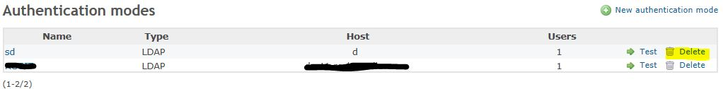

Pop-up message appears

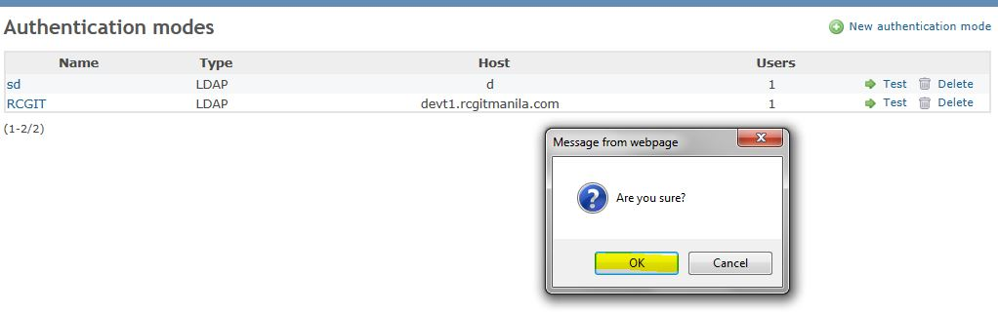

nothing happen after hitting OK button.

Additional Info

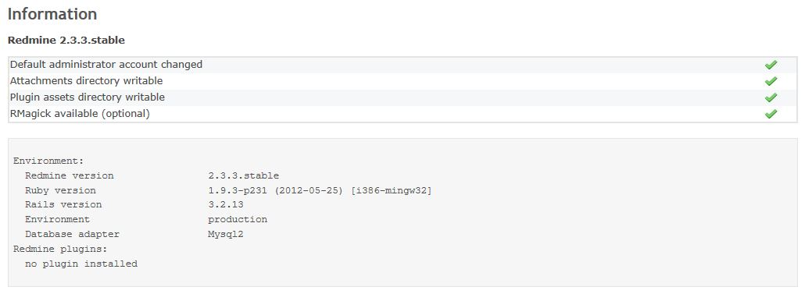

My installation of Redmine was installed using Bitnami Third-party bundles.