**Old server where it is working.**

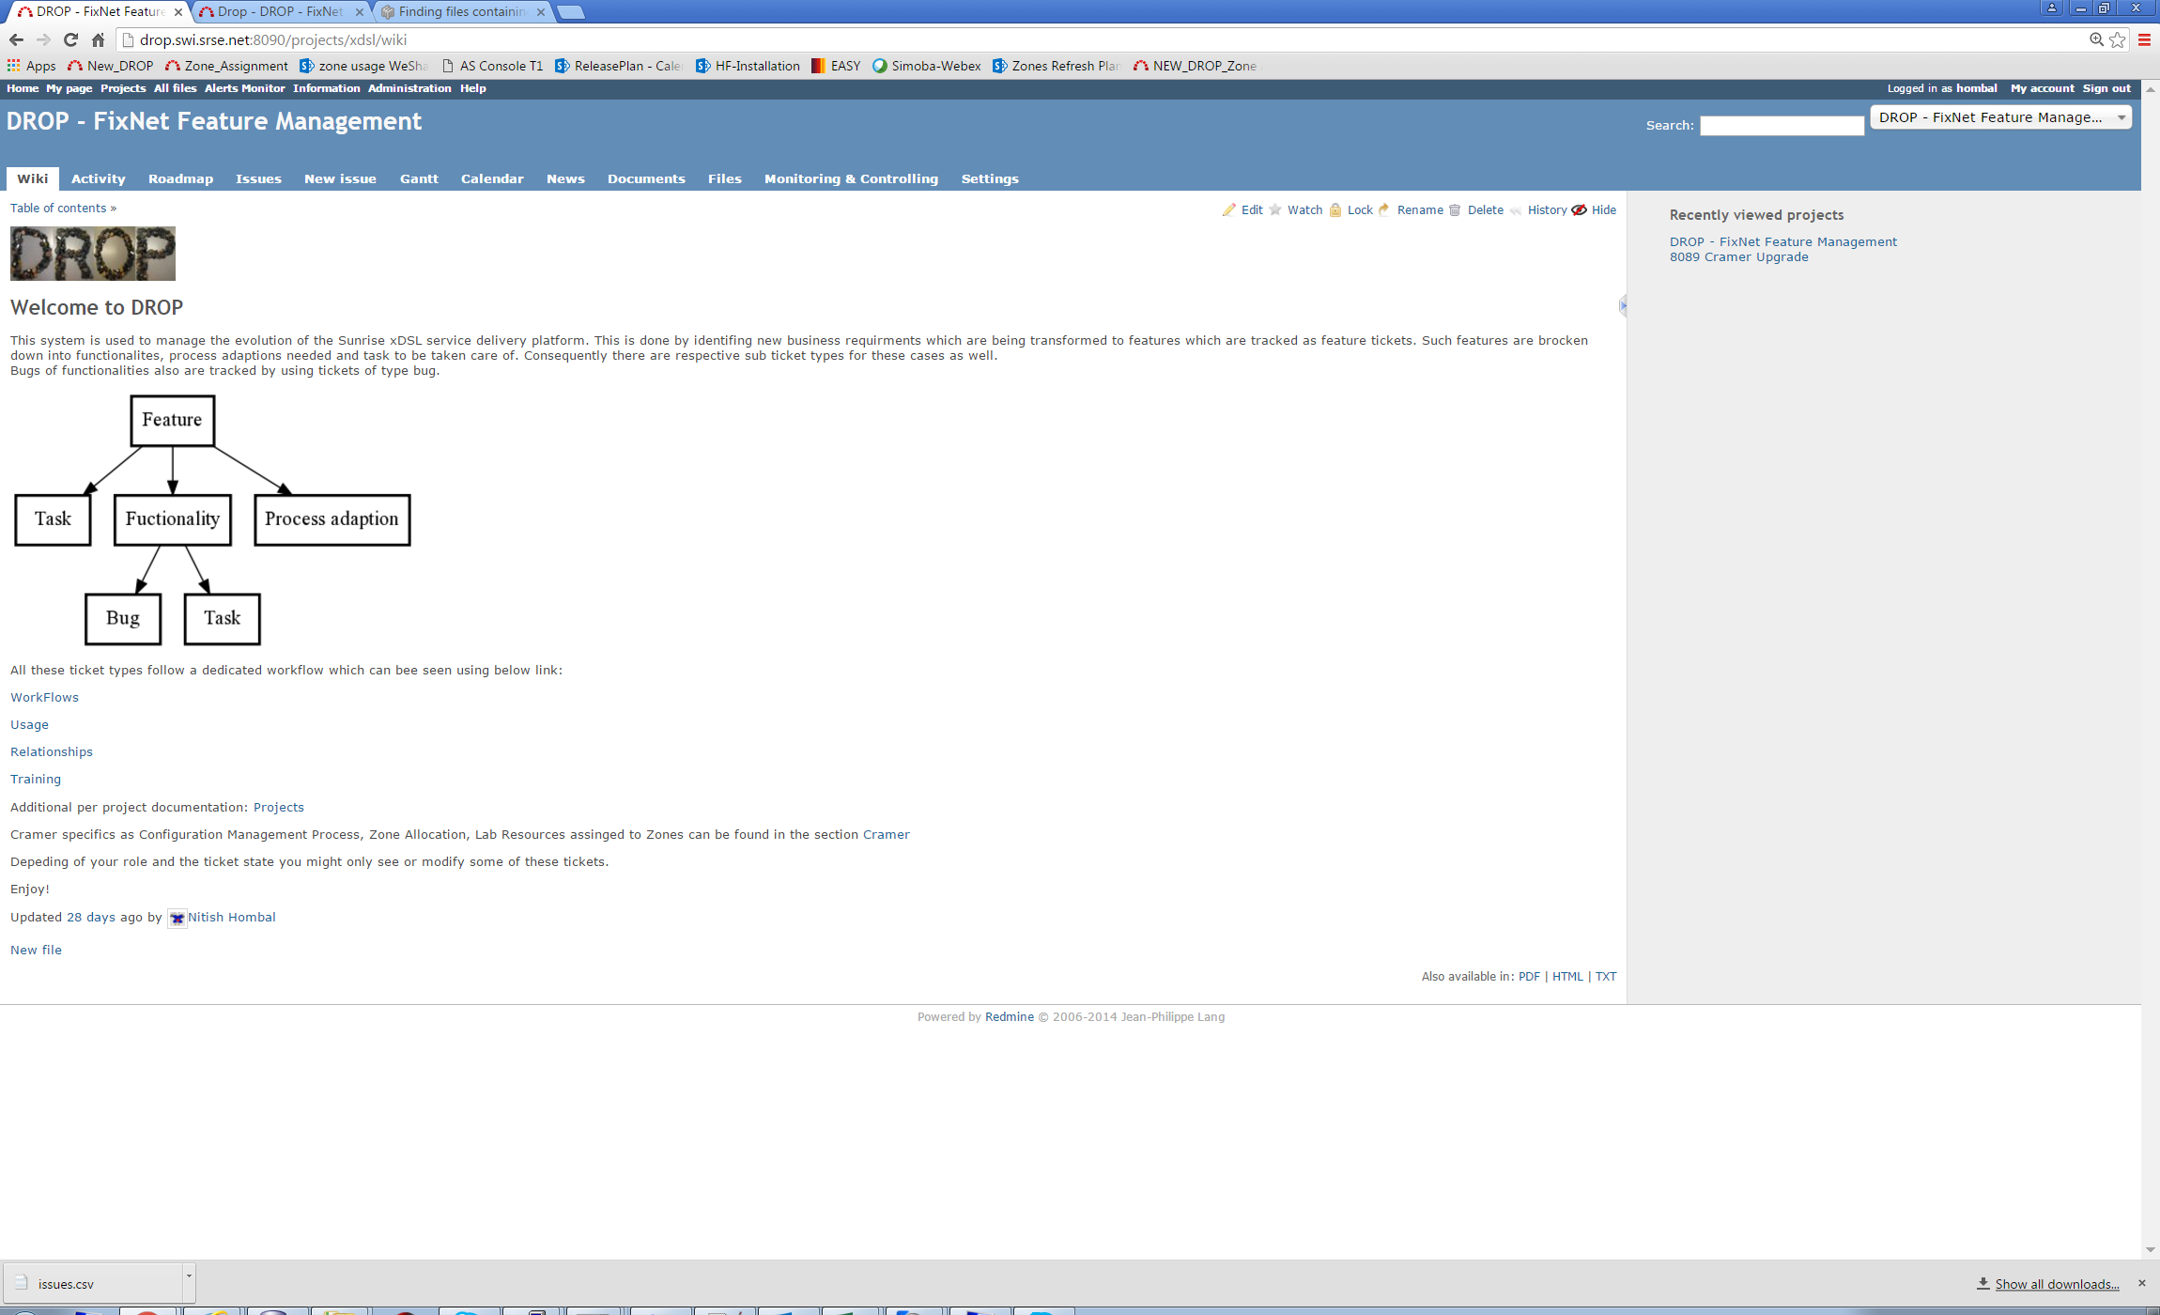

**On new server I get an error and the graph/image is not displayed.**

