Redesigning of Farming Systems Using Multi-Criteria
Assessment Tool for Sustainable Intensification and
Nutritional Security in Northwestern India
A. K. Prusty ^{1,}*, N. Ravisankar ^{1,}*, A. S. Panwar ¹, M. L. Jat ², J. P. Tetarwal ³, Santiago López-Ridaura ⁴, Roos Adelhart Toorop ⁵, Jelle van den Akker ⁵, Jashanjot Kaur ⁶, P. C. Ghasal ¹, Luis Barba-Escoto ⁴, Jeroen C. J. Groot ⁵, Poonam Kashyap ¹, M. A. Ansari ^{1,}* and M. Shamim ¹
Supplementary Material

Table S1. Decision variables and constraints for optimization of each of representative marginal farm households from typology
 | Minimum | Maximum
Decision variables
Land use current crop rotations | 0 | Total arable land (ha)
Land use alternative crops | 0 | Total arable land (ha)
Crop residues to soil (%) | 0 | 100
Chickpea grain (feed) | 0 | 1500
Cotton seeds | 0 | 2500
Groundnut meal | 0 | 1000
Mustard cake (MPF farmer) | 0 | 2500
Mustard cake (MDF farmer) | 0 | 3000
Sugarcane tops fresh | 0 | 3000
Sugarcane tops silage | 0 | 2500
Wheat straw | 0 | 4000
Wheat screenings (delhia) | 0 | 3000
Lentils ('multigrain mix') | 0 | 3000
Constraints
Farm area (ha) | Current area -0.01 ha | Current area + 0.01 ha
Saturation deviation ruminants (%) | -∞ | 3
Energy deviation ruminants (%) | -5 | 15
Protein deviation ruminants (%) | -5 | 30
Organic matter balance (kg/ha/year) | -320 | ∞
Self-reliance household consumed crops | 1 | ∞
Regular Labour balance | 0 | 999
Casual labour balance | 0 | 999
Leisure time | 0 | 999
N Balance | 0 | 999

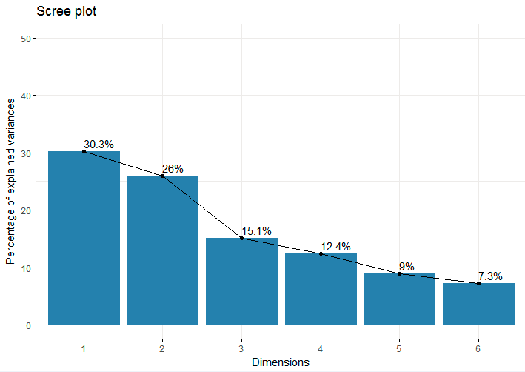
Figure S1. Scree plot of principal components with percentage explained variation
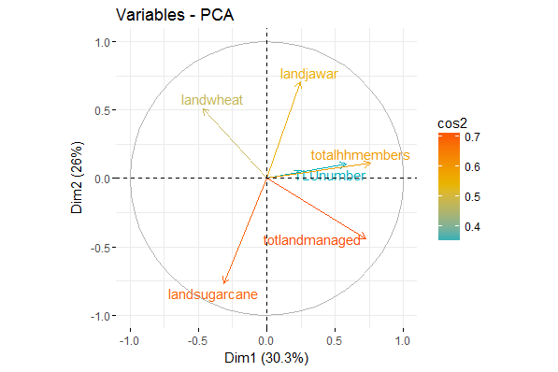
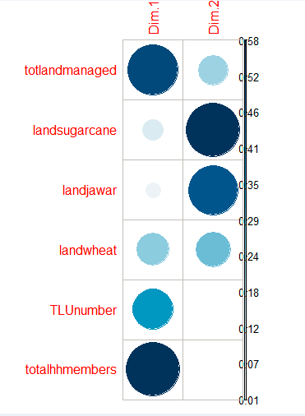
Figure S2 and S3: Variables projected on PCs. Colour code gives cos^2 as means of representation (closer to 1 is more represented)

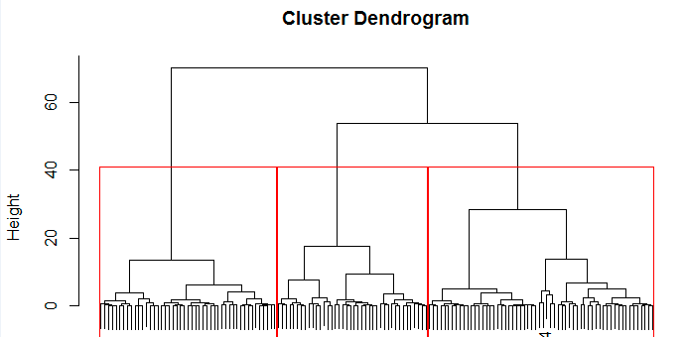

Figure S4. Hierarchical cluster analysis dendrogram with three clusters

