Wrong link in password reset email
We use the following Redmine set up
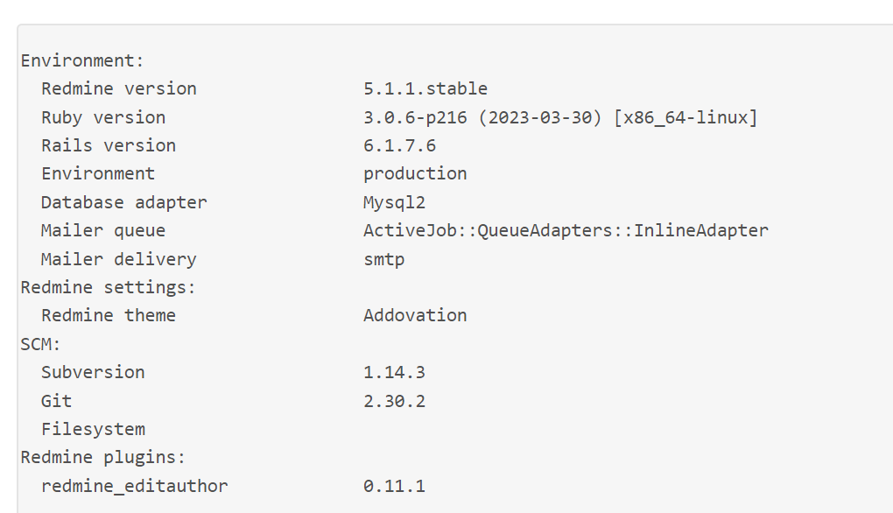
Problem:
A user is clicking on the reset password button and will receive the following page to enter an email:
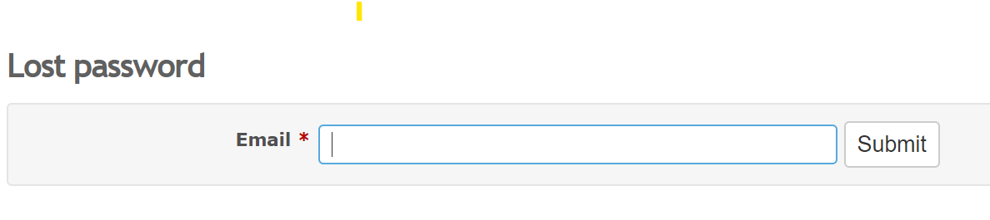
The user receive the following email notification:
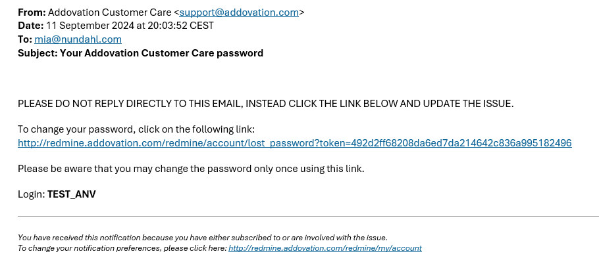
This link is supposed to take you to the password reset page - but it takes you back to the Lost Password page and you have to enter your email again…it will be an endless loop.
This is becoming a huge problem for us, can you please help?
We think this problem started sometimes in April, but we can not find any reason why.
I made a test with my Redmine user account just to check how it should work and when I click the link I got from Redmine to reset my password it worked fine.
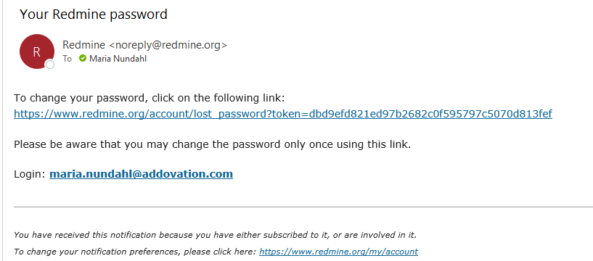
I clicked the link and it took me to this page:
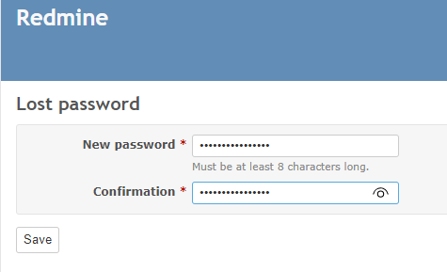
In our set up it takes you back to the email address page..

