I am using Bitnamy Redmine 2.3.0 on Windows 64 bit
- Download and unzip plugin in the following folder.
C:\BitNami\redmine-2.3.0-0\apps\redmine\htdocs\plugins
Is that the right folder?
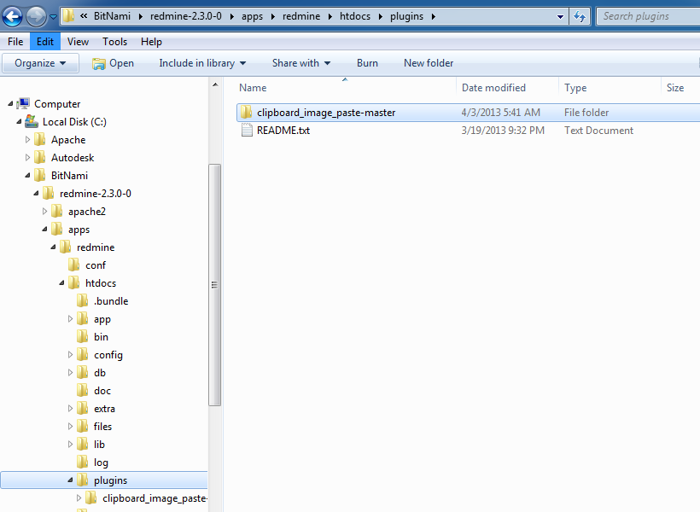

- At this point, following the guidelines at this address (http://www.redmine.org/projects/redmine/wiki/Plugins) I should run the following command from the windows prompt window
rake redmine:plugins:migrate RAILS_ENV=production
But actually I don’t know from which folder I have to run this command or if I need further software installed on my machine.
I typed the command in the prompt from the root as from the plugins folder as from the very plugin folder (in this case clipboard_image_paste-master) and other location that I found typing the word “rake” or “rails” but I always got this message
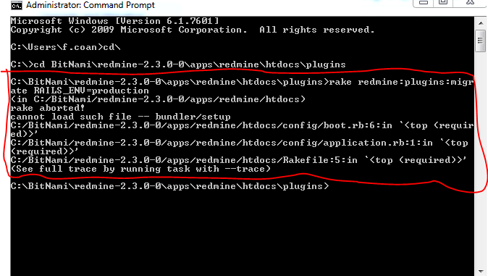

Bottom Line:

I am sure I am missing something, it could be the proper installation folder for the plugin, as some service not active, as my lack of knowledge about Ruby and RoR but I wish that some one can tell me where to start from to get the knowledge needed to handle the plugin installation.

